Sometimes the requestmapping annotation is not interpreted.

Controller class cannot be generated

But you can generate the following content based on the Controller's code explanation above and below.

Only part of the following code explanation is given but more following code can be generated.

Chatgpt4.0 can generate the code directly, but it is not complete due to incomplete code explanation.

Individual functions can be generated

Service class can't generate code directly

But sometimes generated comments can be generated part of the code manually continue to generate the code can be generated after the full code

Chatgpt4.0 can generate code directly, but due to insufficient context, the class name and package name need to be adjusted manually.

However, it is possible to generate the following content based on the code explanations above and below the service (depending on the reasonableness of the code explanations).

It is possible to generate more contextual code with only a partial code interpretation of the context.

Cannot generate entity class content based on code interpretation

Cannot generate xml headers based on code interpretation

Unable to fully interpret all properties of resultmap.

Copilot can't generate mybatis code based on code interpretation.

Chatgpt4.0 can but the mapper interface class is reporting some errors, tell gpt the error message and gpt can correct it.

But it can generate the following template based on the mybatis template code above.

Gpt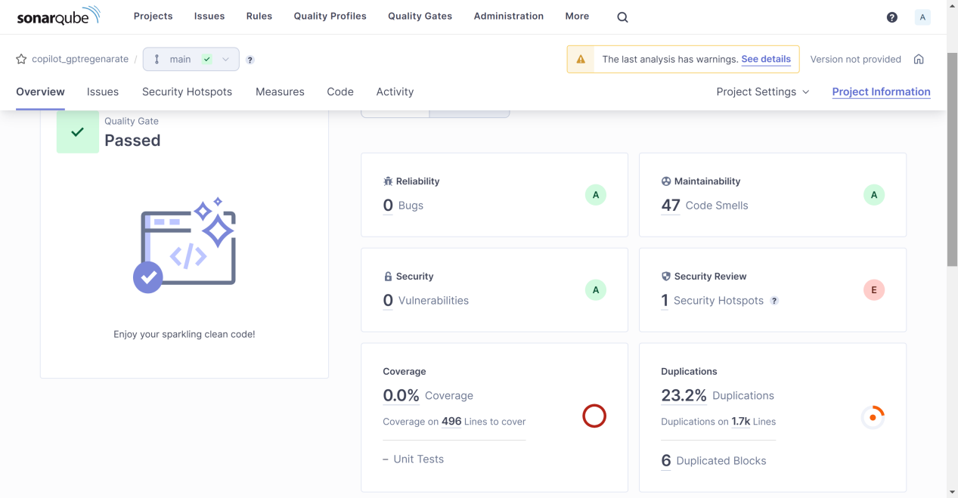

Copilot

